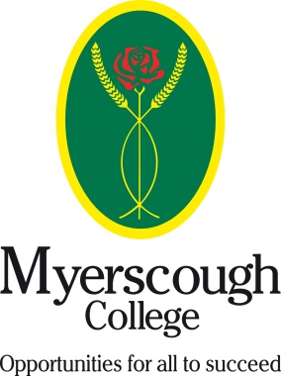
Memorandum of Understanding
Between
Myerscough College and
Practice Name:__________________________________________________
In Confidence
Student name
Course enrolled on | ABC Level 2 Certificate Animal Nursing Assistants Correspondence Course
Myerscough student number
ABC registration number | TBC
Course start date
Anticipated end date

The course provider will:
- Provide work books, access to a virtual learning environment and assessment documents as per the unit detail.
- Mark all work within a three week deadline.
- Provide support to the student and practice as required.
- Detail the practical assessments which must be undertaken and provide support to the mentor on how to assess them.

The Veterinary practice will:
- Provide a qualified member of the team to act as a mentor to the student.
- Provide time to allow practical assessments to be undertaken in a safe environment.
- Allow a member of the Myerscough team to visit for quality assurance purposes to validate assessment decisions.
- Provide a minimum one day per week as training auxiliary role for the student. Either as a voluntary placement or on an employed basis.
- Ensure students & learners who have work placement or are employed as part of their course of study receive an effective opportunity to learn whilst at work, and gain first-hand experience of the subject they are studying. Both the college and employer must place high priority on ensuring that the work placement is a healthy & safe environment and one in which students and learners are safeguarded against potential risks in employment at the Veterinary Practice.

Agreed on behalf of Myerscough College

Signature: Date:

Agreed on behalf of the above named practice

Signature: Date:

Printed Name: Position in the practice:

