HE Equine Practical Skills Workshops
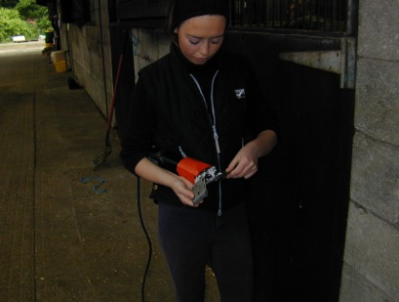
The Myerscough equine department is passionate about ensuring that our HE students have excellent vocational skills, which are so vital to any career within this industry. This value has been regularly praised by our external examiner, industry advisors and most recently by the panel who approved our HE courses.
We understand that most students have other responsibilities and demands away from college and therefore are using this opportunity to let you know what you will be expected to do in the coming year.

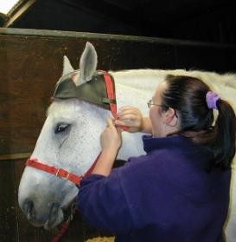
First Year Students
All first year students will work on the yard on Thursdays each week. This will involve a morning session 09.00 – 10.30 and an afternoon session 15.00 – 17.00 during which time you work as a team with your peers and the staff to provide care for the college horses. These sessions will be targeted towards developing the practical skills and knowledge required for the Equine Management module, which is a double credit module (so very important!) Assessments will be directly linked to the experience you are gaining whilst working with the horses and you will be involved in choosing the skills you improve upon or the new skills you learn.
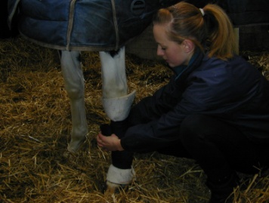
You are also scheduled to cover four weekend practical sessions, which run from 09.00 – 16.00 on Saturday or Sunday. The dates of these are shown below – please ensure that you keep these weekends free in your diary:-
Semester one (Sept – Jan) |  | Semester two (Jan – May)
22 or 23 Sept 2018  3 or 4 Nov 2018 |  | 23rd or 24th Feb 2019  27th or 28th March 2019

You will be required to commit to one day of each of the weekends stated above. In addition, you will need to choose an additional two weekend days per semester to fulfil your practical experience requirement. These will be discussed within induction week, where time will be given for you to sign up – please bring your diaries! These will be allocated on a first come first serve basis, so please try to be organised.

Practical equipment
Practical equipment will be checked during your first week as you will be required to carry out a health and safety induction. It is envisaged that you will carry out the yard induction on the Tuesday 11th September. The benefit of the induction is to help you familiarise yourself with the college yard, ensure you are happy with where you find the equipment, the horses and practical staff members you will come into contact with.
Please see the separate equipment list attached for information regarding the equipment you will need. This will be checked and signed off during induction before you can take part in practical sessions.

Charlotte Brigden, Assistant Head of Equine (HE): cbrigden@myerscough.ac.uk / 01995 642355
Susan Schofield, Senior lecturer and Year 1 Course Tutor: sschofield@myerscough.ac.uk / 01995 642222 ext 2419

